**An Official Publication of the Georgetown South Community Council, Inc. 9444 Taney Road Manassas, VA 20110 703-361-4500 www.georgetownsouth.org**

**Winter 2015**

CRIER

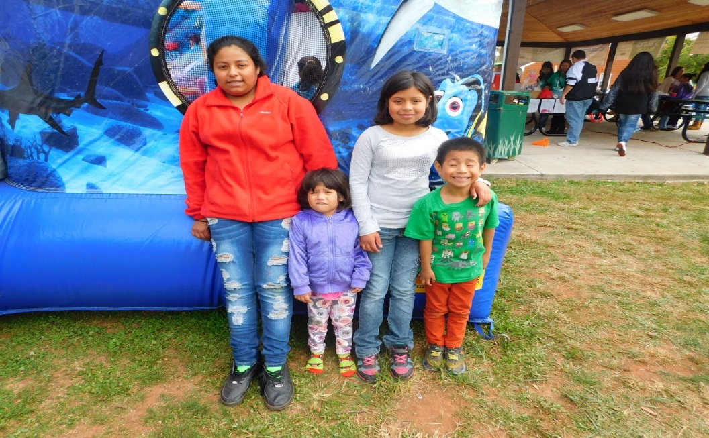Your Pride Outside Fall 2015: A Resounding and UNIQUE Success

Georgetown South: “A Community that Cares for Its Own” has been years in the making. It symbolizes the revitalized Georgetown South wherein the streets and greens are cleaner, the houses are better cared for, property values are up and neighbors take care of neighbors. The most significant evidence of this was seen on Saturday, October 24, 2015 when we held the Fall 2015 Your Pride Outside (YPO) Event. Our YPO events are always successful in terms of trash collection and community cleanup, but this event was uniquely successful in that it also consisted of a Community Yard Sale, a Food Fair, a Small Business Expo, Resource Center, a Carnival and most importantly a Fundraiser for a Georgetown South resident named Reyna Torres. In late August, I was approached by a long time Georgetown South investor telling me of a tenant that he had who was suffering from cancer; some of the women in the community were similarly concerned for her so I went to her house to see how I could be of assistance. What I discovered was that Reyna had been told by her doctors at the University of Virginia that she was suffering from gastrointestinal cancer had six to nine months to live. Reyna had a strong will to live, but more than that she wanted to ensure that she was able to get her children home to where they have family to look after both her and the children. I immediately opened a GoFundMe account and published her story on Facebook.

While we were able to help Reyna online using Go Fund Me, the major fundraiser occurred during our Your Pride Outside Fall 2015 event on October 24th bringing in people from all over Manassas as well as outside the area. In total, over $7,200 was raised in a single day by Georgetown South: “A Community that Cares for Its Own”.

The **Special Parking District** is back and is in full enforcement. If you are a resident of Georgetown South, you must display the Zone 1 sticker to park your car in the community between the hours of midnight 12 AM and 6 AM. These stickers are available for purchase from Manassas City Hall (9027 Center St.) between the hours of 8:30 am and 4:30 pm, Monday through Friday. If you plan to have visitors, they must display a Visitor’s Pass also available at City Hall. Any questions about the Special Parking District should be directed to 703-257-8242. The Georgetown South Office cannot issue Zone 1 passes, Visitor Passes or answer questions related to the Special Parking District. If you receive a fine pay it quickly as the fine amount doubles in 30 days.

**Community Manager Update:** This timelast year I was “Woman of the Year” in the Manassas Christmas Parade, while this year I am at Day 17 post stem cell transplant. I was discharged from the Johns Hopkins University Hospital on Thursday, Day 14 or December 3, 2015. I am recovering at home now still with full-time caregivers until I recover my strength. I am also 100% immune compromised meaning I have no immunity whatsoever for at least three months to a year. We will know in about 60 days to six months if the stem cell transplant was successful; I don’t have to wait for results, I already know that it worked, that it will keep me in remission for many years, and that while I may die with multiple myeloma, I will not die because of it. I thank all of you for your prayers and positive thoughts. They along with the hard work of my medical providers and caregivers have brought about this cure. I will continue to work from home part time until my immune system improves as well as my physical endurance. Right now, I am working only on “essential” things and for me that is to ensure that our children have the best holiday season ever. That means that I am asking that if you would like to adopt a child or a family, or just donate a gift or gifts for children 0 – 18, my staff will ensure that they find a worthy child. You may drop the present off unwrapped at the Georgetown South office any day between now and December 21st. The parents who have participated in the Loyalty Card Program (see below) will benefit from these gifts. I do believe that what we do for our residents is attracting people to Georgetown South as a place to start and raise a family.

**Distribution of Toys for Tots Gifts!**

If you registered your child to receive Christmas gifts don’t forget that the gifts will be distributed on December 22, from 12:00pm to 5:00pm at the Georgetown South Community Center on 9444 Taney Road. Be sure to come as there will not be any other scheduled days if you are not able to make it. We cannot make exceptions and distribute gifts earlier or later. The gifts will ONLY be distributed on that day.

**Loyalty Cards**

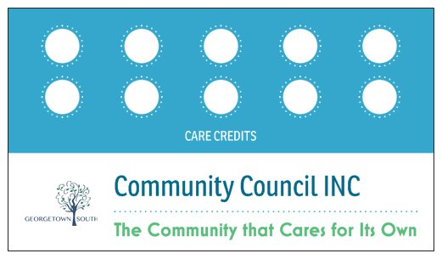The Georgetown South Community Council, INC hosts many events for our residents that are of incredible value to them, but unfortunately they are poorly attended. We also host numerous events such as Back to School Supply Giveaways and Toys for Tots that are very popular because we give things away for free. The Georgetown South Community Council wants to make sure that our residents are informed about their rights and responsibilities and how to take advantage of all this community has to offer. The advantage to you from attending classes and workshops aside from becoming educated is that you will receive additional benefits at our giveaway events. The more holes or “Care Credits” that you have punched, the more benefits you will receive. We will begin with the Toys for Tots Registration. To qualify for priority shopping, you should attend as many of the following classes and workshops that you can. Register early for them at the Georgetown South Community Council office. Come to the Georgetown South office and get your Loyalty Card today. Make sure and write your name on the card. Loyalty Cards are non-transferable. The sooner you register, the sooner you will receive benefits. There are no “free rides” in the revitalized Georgetown South: A Community that Cares for Its Own.

**2015 Property Inspections**

We wish to convey our gratitude to all of our investors and homeowners who worked on correcting any violations for 2015. We have seen consistent improvements to the properties, bit investor owned and resident owned during the last three years. Investments made in fencing, new roofs, new siding and maintenance of the properties have all resulted in higher property values throughout the community. The aesthetics of the community combined with the significant decrease in crime, and the positive image of Georgetown South as portrayed by media based on events unique to our community have all resulted in a revitalized community that can make us all proud. For those homeowners and investors who are not in compliance, you should pay attention to our phone calls and certified letters. You’re already accumulating fines from this year and possibly prior years, so please pay attention and call our office as soon as possible at 703-361-4500 or email [office@georgetownsouth.org](mailto:office@georgetownsouth.org). Thank you for to those who did cooperate this year and we hope that 2016 will be even better and those who have violations now will be in compliance by then.

Thank you,

***Georgetown South Office***

INSPECTION 2014 SAME PROPERTY-INSPECTION 2015

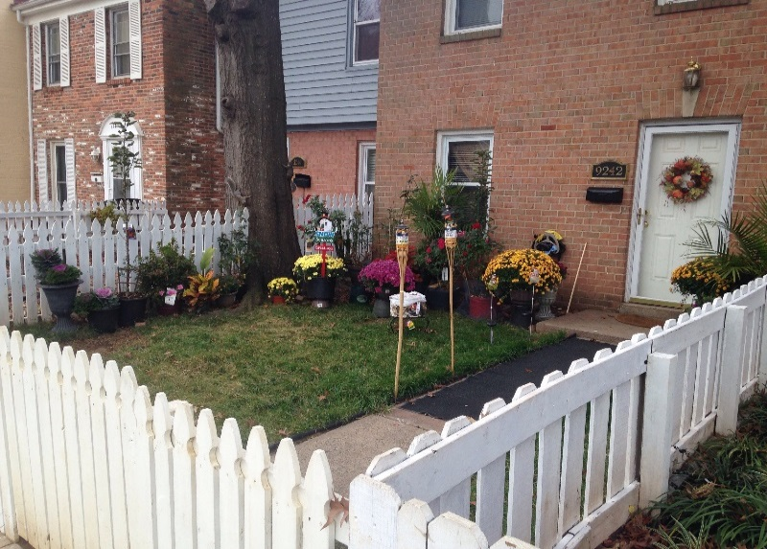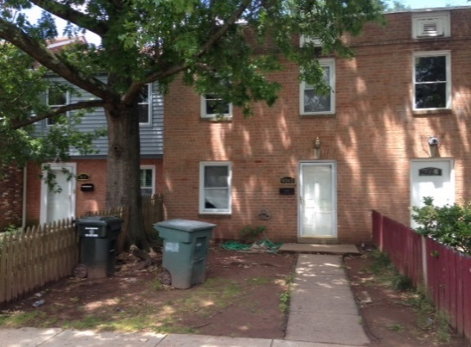

**The difference between 2014 and 2015 amounts to less that $50 in plants and another $50 in sod. What is priceless is the labor and pride that went into maintaining the property.**

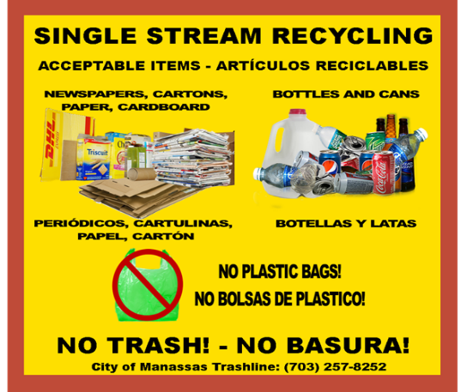**Holiday Trash Rules and Schedule**

Christmas is the busiest time of the year to collect garbage and recycling.

Here are some simple things to keep our neighborhood clean during the Holidays.

1. Enclose all garbage in trash bags and then put it in the trash dumpster that City of Manassas provided.

2. Recycle intelligently! You may only recycle paper, cardboard, cans, bottles. Please no plastic bags. See the photo as a guide to what can be recycled and what cannot.

3. Fold all cardboard boxes and put aside by recycle bin to be collected.

4. Make sure to call at least 24 hours in advance to notify of additonal trash or large items pick up.

5. Christmas trees may be put out on Monday with green/tree waste. Be sure to remove all christmast decorations off the tree before placing for pick up.

6. Please bag all trash in a responsible manner and do not place on the streets until the appropriate day for collection. Everyone loves beautifully wrapped presents. Please make sure and bag all the used gift wrap and place in a tightly closed trash container so it does not blow loosely across the streets and common areas. This is a special request on behalf of the Georgetown South Maintenance Staff to all homeowners and residents of this community. If the garbage container that you have is not enough; you can buy one from the office of Georgetown South for $50.00. For more information please call Trash and Recycling at (703)257-8252 or visit www.manassascity.org/trash

Vandalism will not be TOLERATED in Georgetown South

We have had several instances of vandalism in the community recently including graffiti and other types of destruction of property. Some of the graffiti was gang-related which is a sign that either gang members live here or they frequent the community. The crime rate in Georgetown South has decreased significantly over the past four years and we intend to keep it that way. The management of Georgetown South intends to press charges against any person involved with or suspected of vandalism in this community. Gang-related graffiti and vandalism carries with it minimum, mandatory penalties of incarceration, rather than community service.

Don’t let your children get involved in crime; get involved in your children’s lives. Take note of how they dress, who their friends are, their school attendance and their after school and weekend activities. Enforce rules with consequences. If you have continuing problems with them seek help at their school or through the police department.

**Holiday Decorating Contest**

**The Annual Holiday Decorating Contest will be held on December 21st... Holiday lights and decorations must be ready for viewing by 6 pm. Judges will review all houses in Georgetown South to determine those best decorated for the holiday season and spirit. Gift card prizes will be awarded in the following amounts:**

**1st prize $100.00, 2nd Prize $75, 3rdprize will be awarded to two homes in the amount of $50 and one 4th place prize of $25. Prizes will be presented on December 22.**

**Community Center Reservations**

Are you planning on having a party or hosting a business meeting in 2016? We have the ideal space for you to do so, but you must makeyour reservations early. We have a large, attractive community room that can be rented at an affordable price and best of all it is located in your community. If you have any questions and/or you would like to check availability call Victoria at 703-361-4500 or email her at [vrichardson@georgetownsouth.org](mailto:vrichardson@georgetownsouth.org)

**Contact List - Board of Trustees**

|  |  |  |  |
| --- | --- | --- | --- |
| Name | Title | E-mail | Address |
| Janeth Nobles-Reyes | President | [jnobles@georgetownsouth.org](mailto:hsenft@gtownsouth.com) | 9461 Taney Rd  Manassas, VA 20110 |
| Friday Pamie George | Treasurer | fpg@georgetownsouth.org | 9231 Arnie Court  Manassas Park, VA 20111 |
| Hannah Senft | Vice President | [hsenft@georgetownsouth.org](mailto:hsenft@georgetownsouth.org) | 9616 Aspen Pl  Manassas, VA 20110 |
| Leslie Jones | Trustee | [lesliegjones5@gmail.com](mailto:lesliegjones5@gmail.com) | 6120 Olivera Ave.  Bealeton, VA 22712 |
| Grailing Carter | Trustee | gcarter@georgetownsouth.org | 9863 Buckner Rd  Manassas, VA 20110 |
| Jairo Castillo | Secretary | [jcastillo@georgetownsouth.org](mailto:jcastillo@georgetownsouth.org) | 9733 Bragg Ln  Manassas, VA 20110 |
| Olive Palmer-Davies | Trustee | [olive@georgetownsouth.org](mailto:olive@georgetownsouth.org) | 9700 Beech Pl  Manassas, VA 20110 |

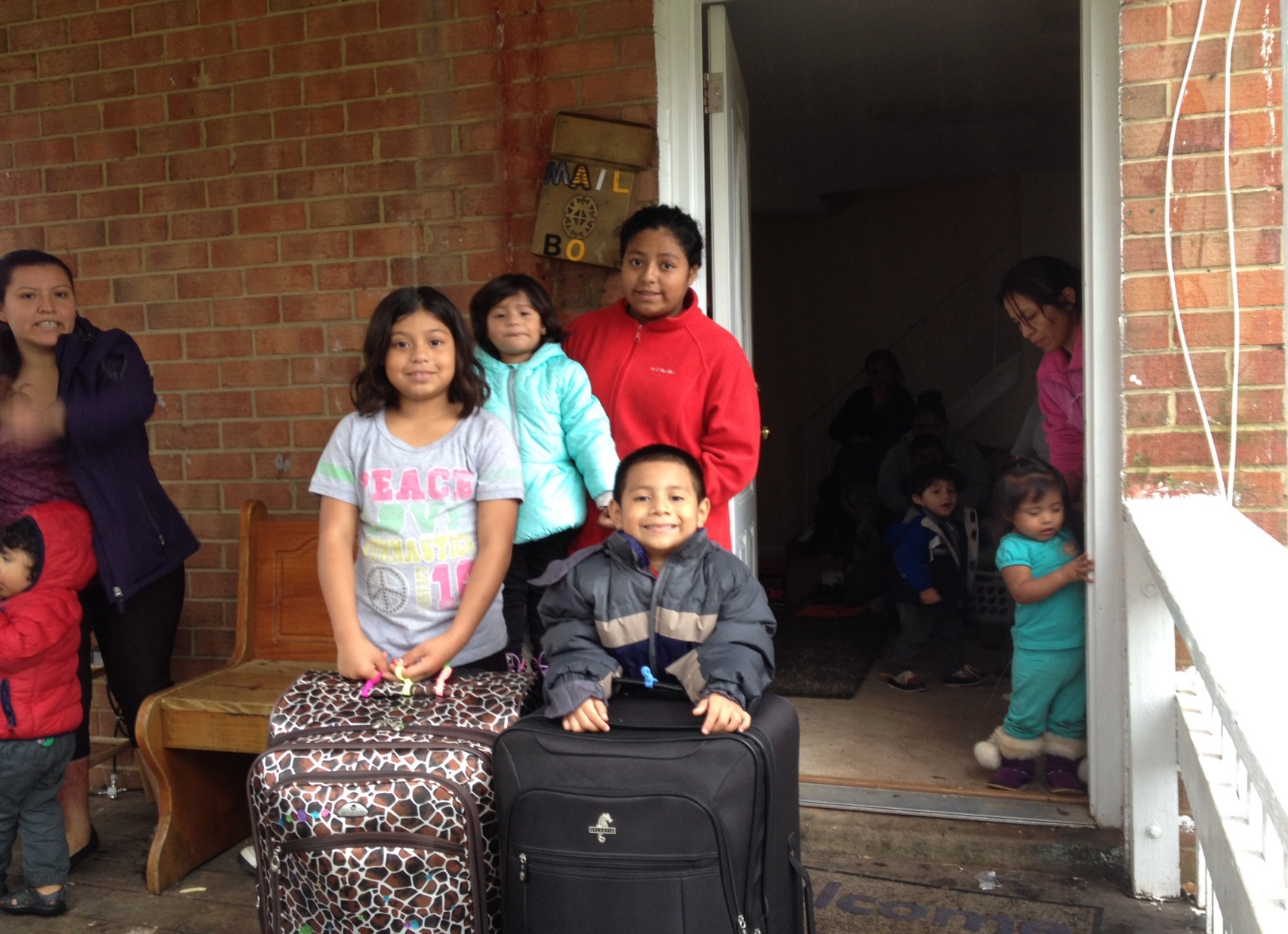 **REYNA Update**

Reyna and the children left for Mexico on Thursday, November 19th. The Mexican Consul was generous in sending a medical professional to look after Reyna during the flight plus another person to assist with the kids until they reached the airport in Mexico City where they were greeted by family members to include their grandmother who they had never before met. Grandma says that Reyna spends much of her days sleeping due to the medication she is taking. The kids have not been enrolled in school yet so they could enjoy more time with their mom, but Grandma will be enrolling them soon as she sees that Reyna is too sick to appreciate their presence at the house all day+. The kids are making friends and getting to know new family members while also getting to know a new culture. Their father is also waiting in the wings ready to take responsibility for his children, but understanding that they need to be with their mother now. I will be closing the GoFundMe account and the Fundraising Account on Friday December 18th. You can still donate up until that time and I know your gift will be appreciated and used in a worthy fashion.

Although expected, this new breaks my heart, [Reyna Torres](https://www.facebook.com/reyna.torres.948) has gone to be with God leaving behind four young children that I hope are loved and cared for all the more given their mom's passing at such a young age. Since much of the viewing will be done at the home, the children’s' father has come to take them to be with him. I just spoke to someone in touch with Reyna's sister - she says the family will need help with the funeral expenses. I really want to hold back on sending the money we have collected thus far as that was always meant to be the children's inheritance. If you can donate towards funeral expenses you can make a check payable to: Margaret Carroll and in the notes section put Reyna. You can then mail it to or drop it off at the Georgetown South Community Council Office at 9444 Taney Road., Manassas, VA 20110. Any questions, call 703-361-4500 that is the number I can't be involved in this at all as I am still in my immunity bubble until the end of January. Thank you for all you do as you care for this woman who died too soon and her children. God bless them, protect and love them now and forever. Amen. Please share this information so that all who knew Reyna will get the news of her passing.

|  |
| --- |
| Events Calendar |

|  |  |  |  |  |
| --- | --- | --- | --- | --- |
| Date | Time | Event | Location | Address |
| 12/17/15 | 5:30pm | Northern Virginia Family Services: Parenting Class | Community Center | 9444 Taney Rd |
| 12/18/15 | 6:45-8:45 pm | Rental Success: Understanding the lease & Getting back your security deposit | Community Center | 9444 Taney Rd |
| 12/21/15 | 6:00pm | Holiday Christmas Decorating Contest | Georgetown South | All GTS Streets |
| 12/22/15 | 12-5pm | Christmas gifts distribution to those who registered | Community Center | 9444 Taney Rd |
| 12/22/15 | 10-5pm | Holiday Decorating Contest winners will be announced. | Community Center | 9444 Taney Rd |
| 12/24/15 |  | GTS Office closed due to Holiday | Community Center | 9444 Taney Rd. |
| 12/25/15 |  | GTS Office closed due to Holiday | Community Center | 9444 Taney Rd. |
| 1/1/16 |  | GTS Office closed due to Holiday | Community Center | 9444 Taney Rd |
| 1/8/16 | 11:45-2:00pm | Home ownership: Working with a realtor | Community Center | 9444 Taney Rd |
| 1/15/16 | 6:45–  8:45 pm | Rental Success: Life as a renter/ Right Responsibilities | Community Center | 9444 Taney Rd |
| 2/5/16 | 11:45 am- 2:00 pm | Home Ownership: Working with a mortgage lender | Community Center | 9444 Taney Rd |
| 2/7/16 | Midnight | Deadline for Board of Trustees’ Candidates’ Applications to be submitted. | Community Center | 9444 Taney Rd |
| 2/19/16 | 6:45-8:45pm | Rental Success: Housekeeping Repairs/ Right way to terminate the lease | Community Center | 9444 Taney Rd |
| 3/4/16 | 11:45 am–2:00 pm | Home Ownership: Insurance for you home | Community Center | 9444 Taney Rd |
| 3/08/16 | 7:00pm | Annual Meeting | Community Center | 9444 Taney Rd. |
| 4/1/16 | 11:45 am–2:00 pm | Home Ownership: Foreclosure Prevention | Community Center | 9444 Taney Rd |
| 5/6/16 | 11:45 am-2:00pm | Home Ownership: Home inspection and Home maintenance | Community Center | 9444 Taney Rd |

**We give special thanks to New Beginnings Worship and Deliverance Center for bringing a sit down Thanksgiving Dinner to our community. 130 people were served between two seatings at the Community Center where food, faith and fellowship were the order of the day.**

**We give another special thanks to Rescatando and Grace Redemption Family Workship Center for providing more than 140 turkeys along with other items to cook on Thanksgiving Day to the Georgetown South residents.**

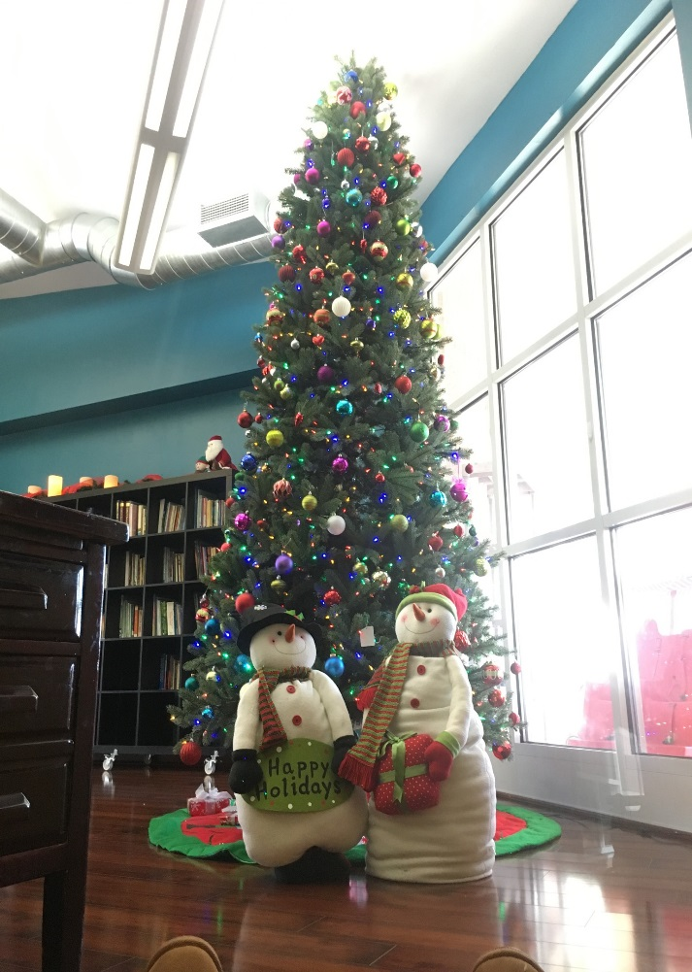

**The Board of Trustees and the entire staff of the Georgetown South Community Council wish all of you a blessed, happy and safe holiday season and a new year full of good fortune and good health for you and your loved ones.**

**Mark your calendars, our Annual meeting will be held on Tuesday, March 8th, 2016 at 7:00pm in the Georgetown South Community Center.**